Name: Zain ul Abideen

Reg no.: 4138-FBAS/BSSE/F20

Sub: Software Development & Construction

Department: Software Engineering

Submitted to: Sir Shakir Rasaheed

Assignment No 2:

CODE:

#include <iostream>

using namespace std;

bool isLeapYear(int year) {

if (year % 4 == 0 && year % 100 != 0) {

return true;

}

else if (year % 400 == 0) {

return true;

}

else {

return false;

}

}

void printCalendar(int year) {

cout << "YEAR: " << year << endl;

for (int month = 1; month <= 12; month++) {

cout << "MONTH: " << month << endl;

cout << "MON TUE WED THU FRI SAT SUN" << endl;

int daysInMonth;

if (month == 2) {

if (isLeapYear(year)) {

daysInMonth = 29;

}

else {

daysInMonth = 28;

}

}

else if (month == 4 || month == 6 || month == 9 || month == 11) {

daysInMonth = 30;

}

else {

daysInMonth = 31;

}

int dayOfWeek = 1;

for (int day = 1; day <= daysInMonth; day++) {

if (day == 1) {

for (int i = 1; i < dayOfWeek; i++) {

cout << " ";

}

}

if (day == 29 && month == 2) {

cout << "[" << day << "]";

}

else {

cout << " " << day << " ";

}

if (dayOfWeek == 7) {

cout << endl;

dayOfWeek = 1;

}

else {

dayOfWeek++;

}

}

cout << endl;

}

}

int main() {

int year;

cout << "Enter year (Fout Digit): ";

cin >> year;

if(isLeapYear(year)){

true;{

cout<<"This is Leap Year.\n";

}}

else

{

cout<<"This is not Leap Year.\n";

}

cout << endl;

printCalendar(year);

return 0;

}

Snap Shots:

Taking input from user:

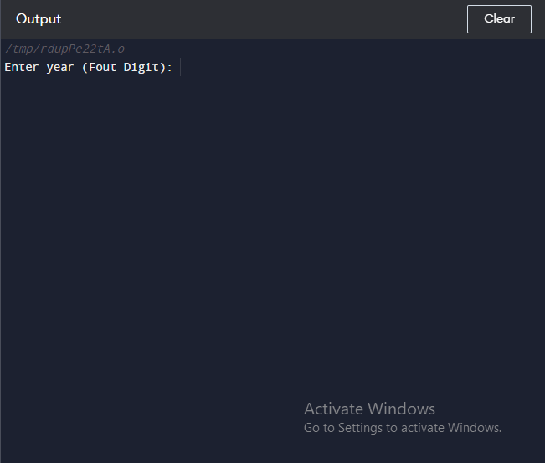

Showing Leap Year:

Date is highlighted in Quotations.

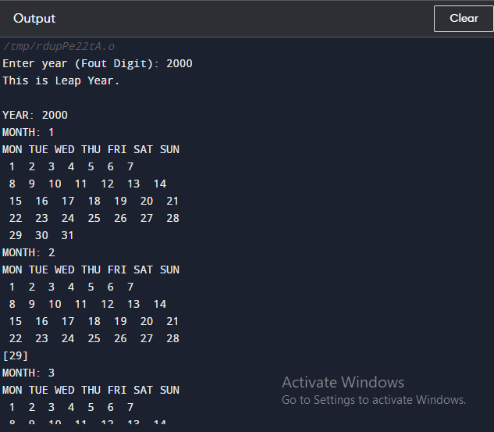

Showing its Not Leap Year:

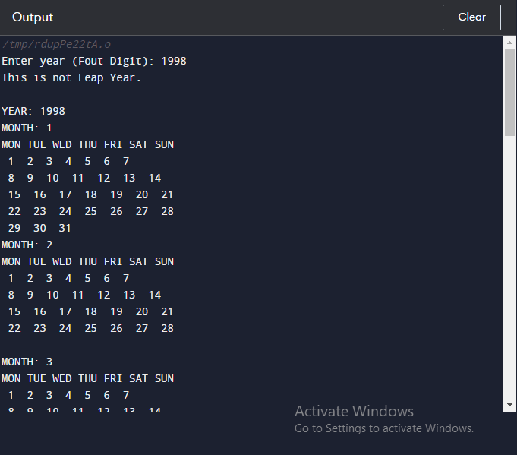

THE END